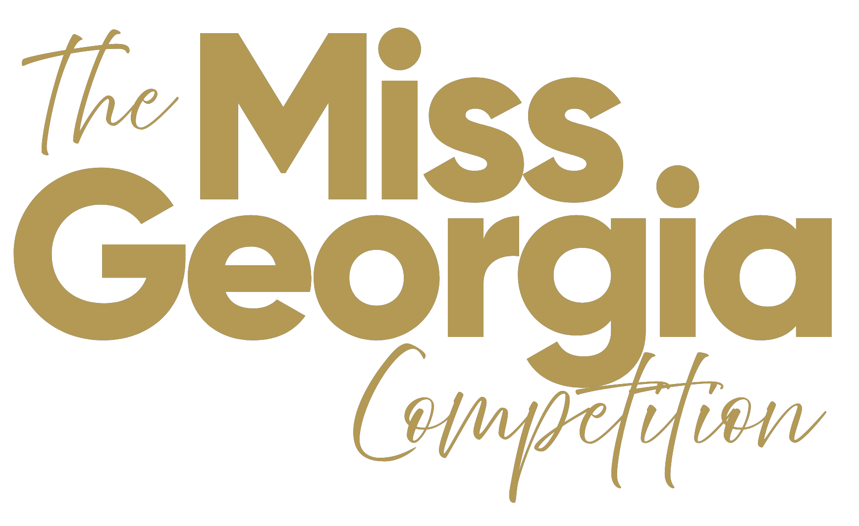
COMMUNITY SERVICE INITIATIVE (CSI)
Miss America’s Community Service Initiative (CSI) is an integral part of the interview phase of competition, supporting one of the branded elements of Miss America as outlined by the “Four Points” of the crown. The “Four Points” are Style, Scholarship, Service and Success. CSI is specific to the SERVICE point of the crown.
The CSI initiative allows you, as a participating Delegate, to showcase and deploy your interests and creativity, to outline a plan or effort to engage within your local community or state existing programs. You may also design your own program for your community or state.
This ONE page submission in san-serif font style of your choice, font sizes from 11-14 only, should include the following:
- A description of your Community Service Initiative passion or interest
- Why you chose this particular initiative
- How you’ve partnered or will partner with local/state communities to create momentum
- Any social media or marketing strategies that will best support your CSI
- Any activities you have planned or participated in with respect to this CSI
Use of Graphics
At the local level, you may use “header only” graphics approximately 1⁄2 inch from the top of the 8.5 x11 page. Graphics may include existing organizations’ logos, taglines or other creative efforts. You may use bullet points within your long form essay. Your local/state organization may decide to have you submit your CSI single page electronically, via a form rather than a pdf, through a portal, or other options.
Signature and Date
Please sign and date your submission at the bottom right hand corner, and include your local title. No submissions to be verified without signature.
NOTE: Marketing & Promotional Suggestion
For personal use/promotion - NOT for an interview submission - you may create a fully graphic page for insertion into a state program book, distribution online as a promotional flyer, printed item to distribute during community events or presentations, or as a ‘one sheet’ to advertise your participation within the Miss America or Miss America’s Teen programs online, or while raising funds. There are no guidelines as to promotional creative, other than you must have State/local permission to use Miss America or Miss America’s Teen logos.

