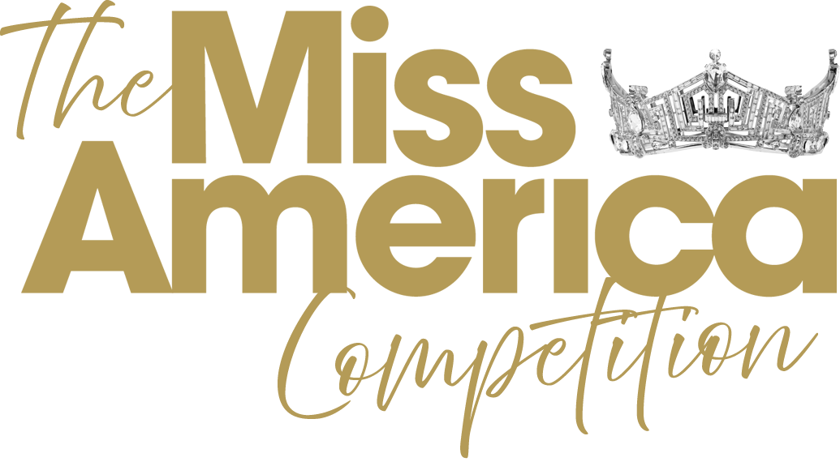

Interview Fact Sheet Instructions

Must be a single page San serif fonts in sizes 11-14.
Margins to be standard 1” Single line spaced typed responses
May be submitted as a hard copy May be filled out as online digital form
May be a PDF
May not include any attachments May not include any graphics or photos

Please see sample below.

Interview Fact Sheet

Name:
Hometown/Local Title:
Age:
Instagram:
Facebook:
TikTok:
Twitter:

Current Employment or Schooling:

Scholastic/Career Ambition:

Community Service Initiative (CSI):

Performance Talent or HERStory™ Description:

Accomplishments:

Interesting Facts:

Describe your personal health initiatives and alignment with #MissAmericaFit:

What social issue, other than your CSI, will have the greatest impact on your generation and why?

Name three items on your ‘bucket list’ in the next five years.

