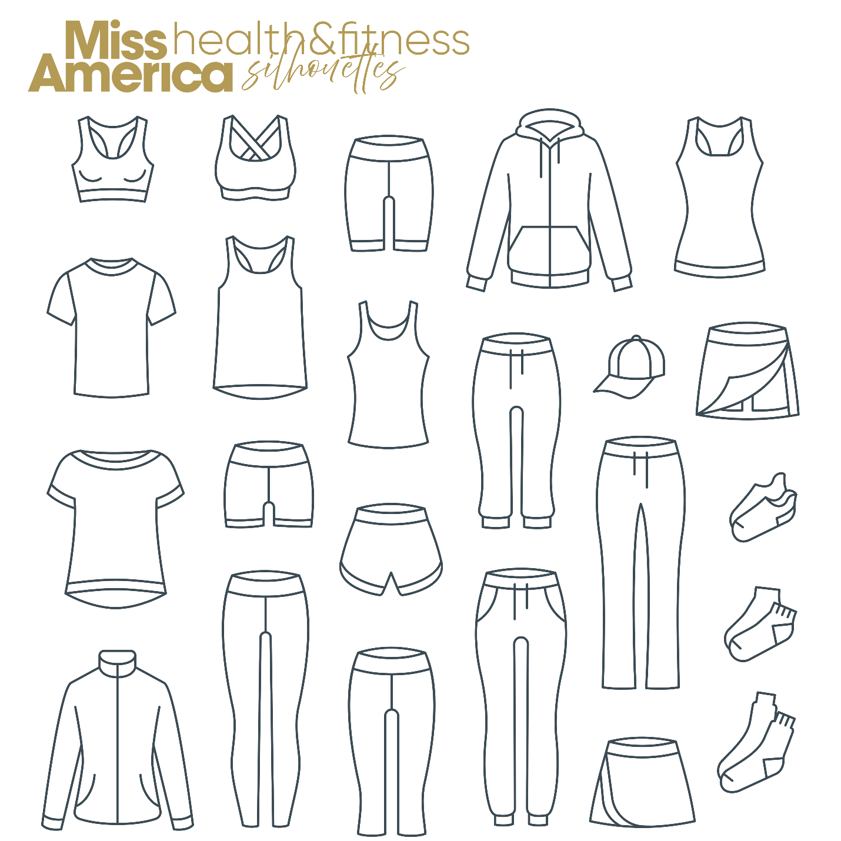
HEALTH & FITNESS COMPETITION in RED
Choose your own outfit but it must conform to one of these samples. Miss America requires that both the top and bottom be RED. You will model this outfit on stage. MAO has a sponsor that you may purchase from if you like. If you wish to use them please contact Jerry Anthony at missuga@uga.edu for instructions and discount code.

