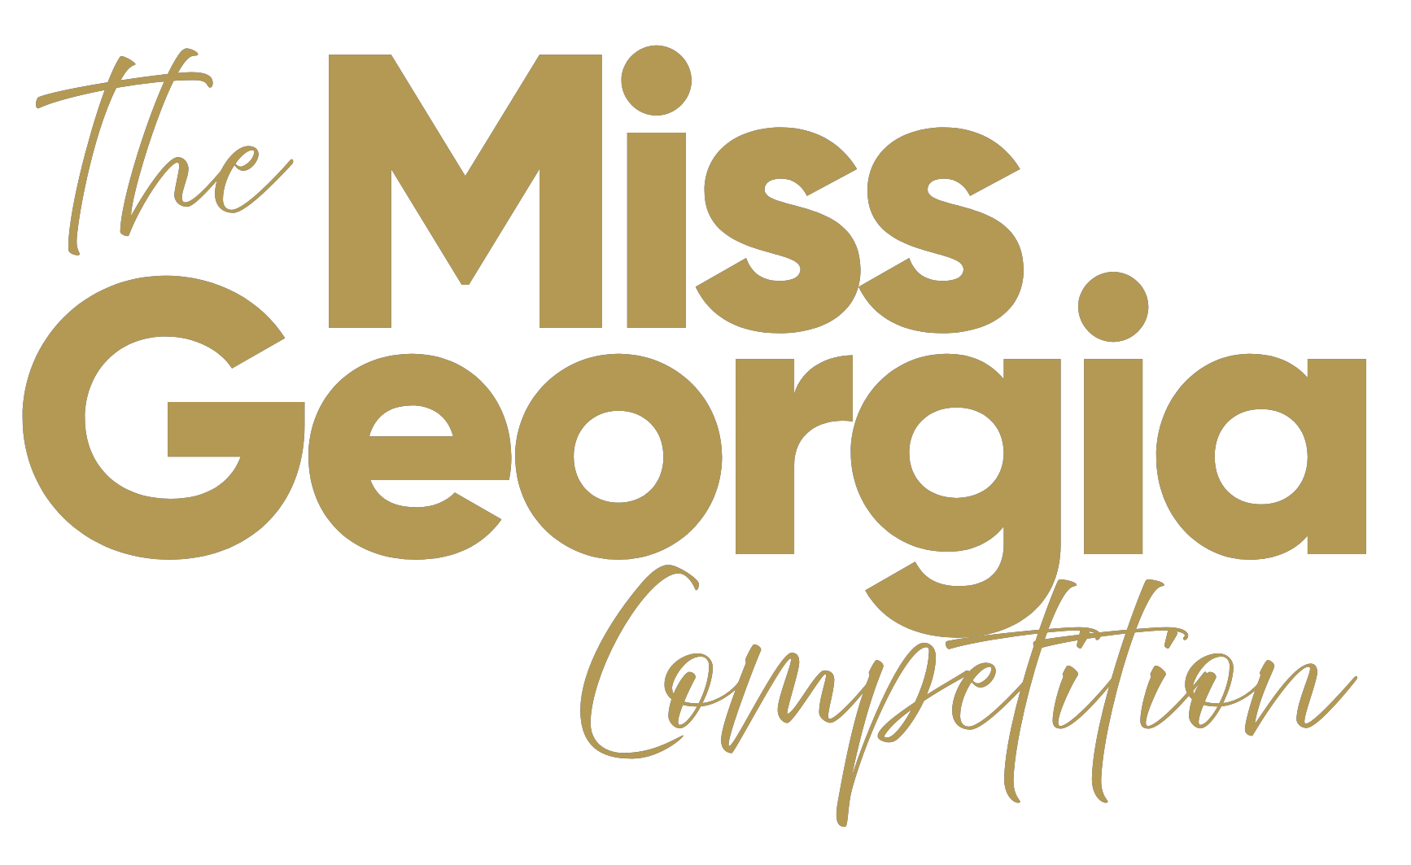

**COMMUNITY SERVICE INITIATIVE (CSI) ESSAY**

Miss America’s Community Service Initiative (CSI) is an integral part of the interview phase of competition, supporting one of the branded elements of Miss America as outlined by the “Four Points” of the crown. The “Four Points” are Style, Scholarship, Service and Success. CSI is specific to the **SERVICE** point of the crown.

The CSI initiative allows you, as a participating contestant, to showcase and deploy your interests and creativity, to outline a plan or effort to engage within your local community or state existing programs. You may also design your own program for your community or state.

This **ONE page submission in (san-serif font) using font sizes from 11-14 only, should include the following:**

* A description of your Community Service Initiative passion or interest
* Why you chose this particular initiative
* How you’ve partnered or will partner with local/state communities to create momentum
* Any social media or marketing strategies that will best support your CSI
* Any activities you have planned or participated in with respect to this CSI

**Signature and Date**

**Please sign and date your essay at the bottom right hand corner.**  No submissions to be verified without signature.

**NOTE:** See the CSI sample document