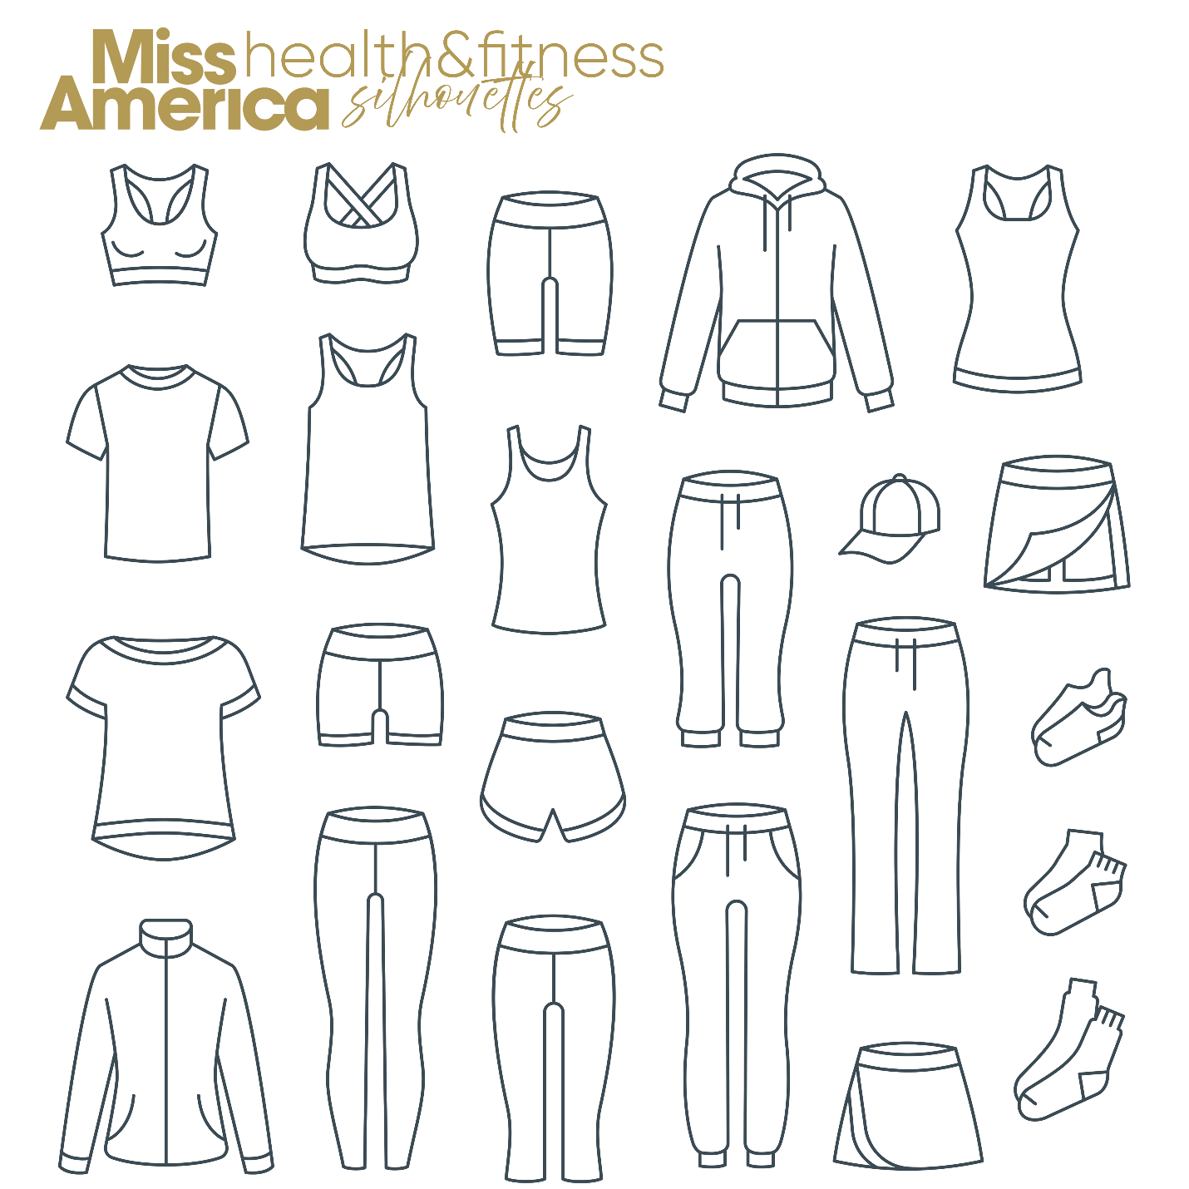

**HEALTH & FITNESS COMPETITION in RED**

Choose your own outfit but it must conform to one of these samples. Miss America requires that both the top and bottom be **RED.** You will model this outfit on stage. MAO’s major sponsor is Rebel Athletics that you may purchase from if you like. If you wish to use them please contact Jerry Anthony at [missuga@uga.edu](mailto:missuga@uga.edu) for instructions and discount code.